**Assignment No.5**

Q) Write a java program to implement Stack using linked list

a. Push an element on to stack

b. Pop an element

c. Demonstrate overflow simulations on stack

d. Display stack

INPUT:-

}

OUTPUT:-

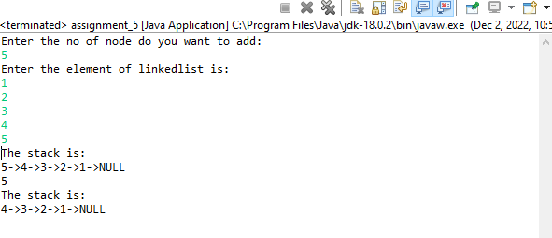

Name:- Yashraj Vijay Aware

PRN no:- 22110167

Roll No.:-224006

Div:-D

Div.:-D1